Adding Video With Captions and Editing Captions

This document will show you how to upload videos in D2L, and edit the captions for accessibility.

Please do not hesitate to contact Jen at the Teaching Learning Center at
303.352.3002 or Jennifer.Maxwell@ccd.edu

- Within a Module, select the Upload/Create button.

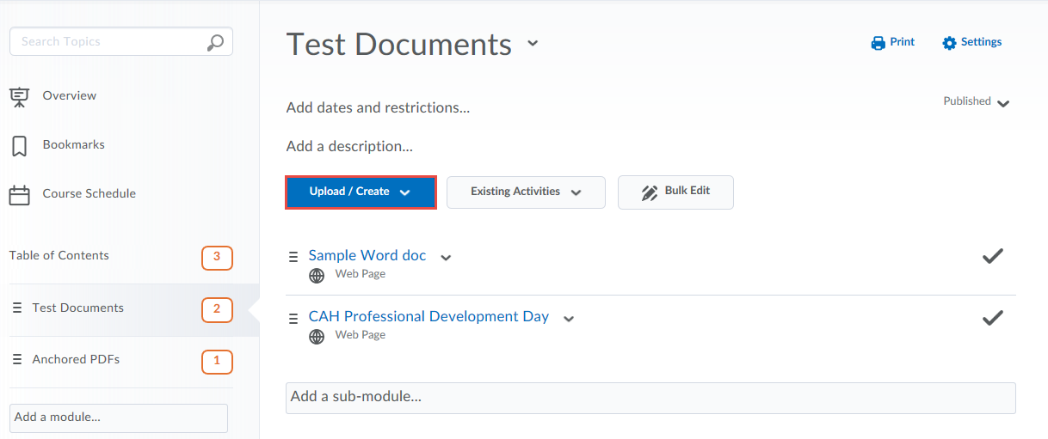

- From the dropdown menu, select Create a File.
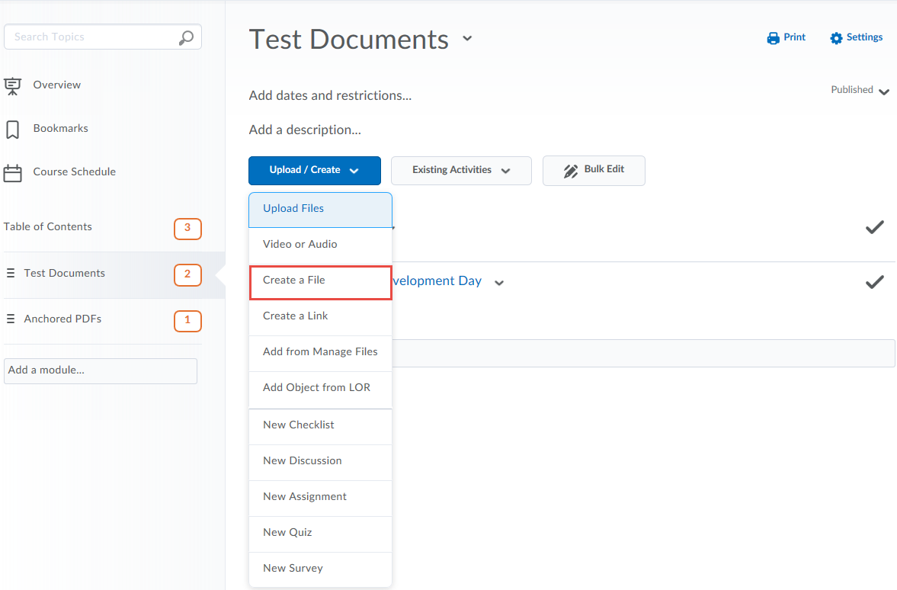

- At the top left of the Create a File editor, Click the Insert Stuff icon.
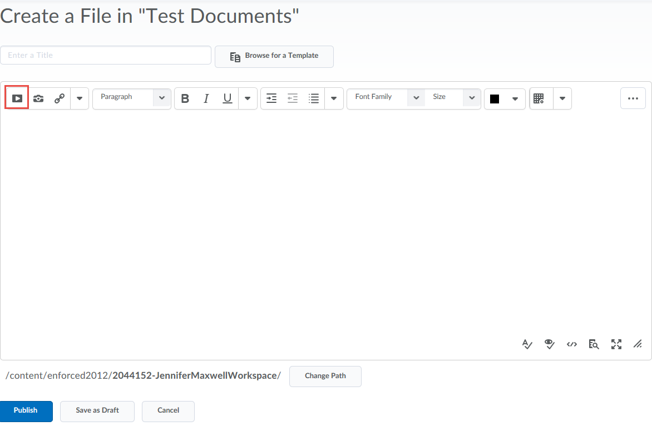

- Scroll down to click on YuJa.
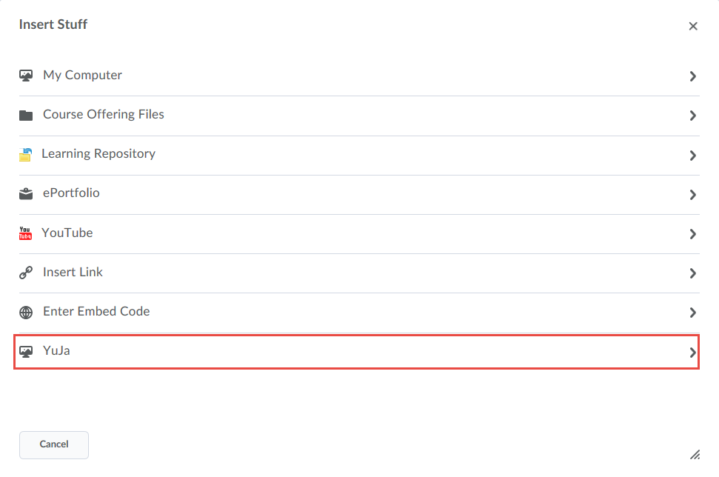

- From the Media Chooser window, make sure the VIDEO option is selected.
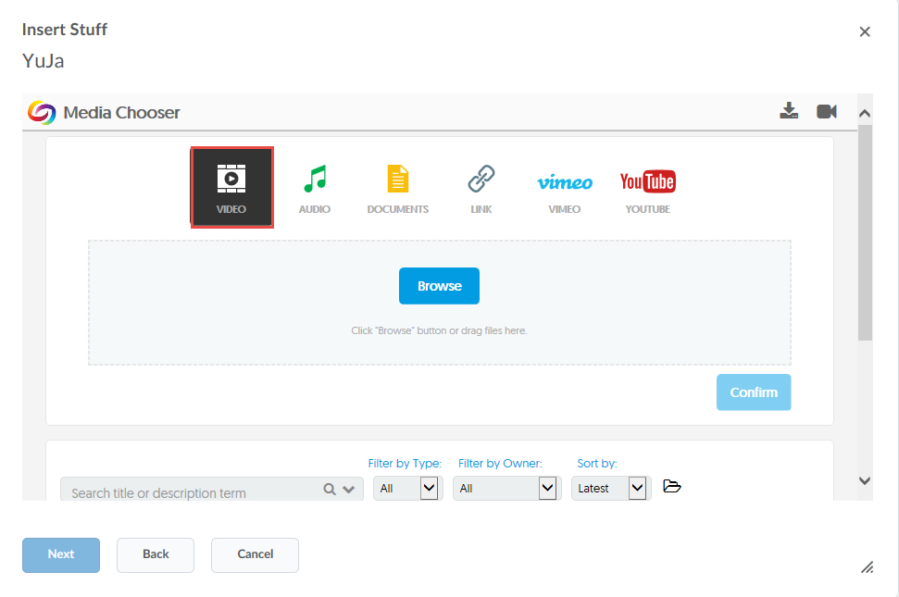

- Towards the center of the window, click Browse.
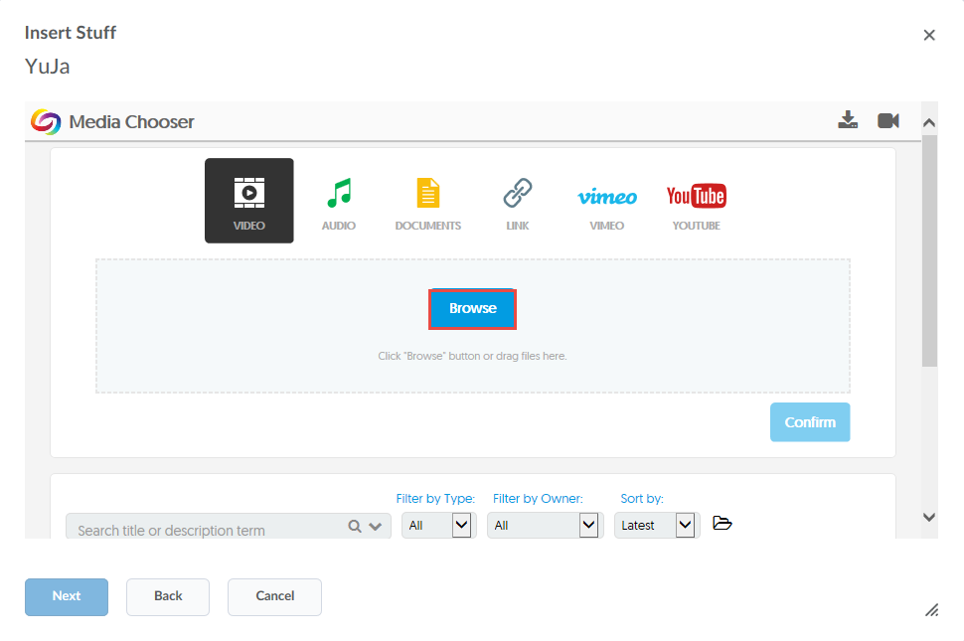

- Select the video, with the .mp4, and click Open. Takes time to load.
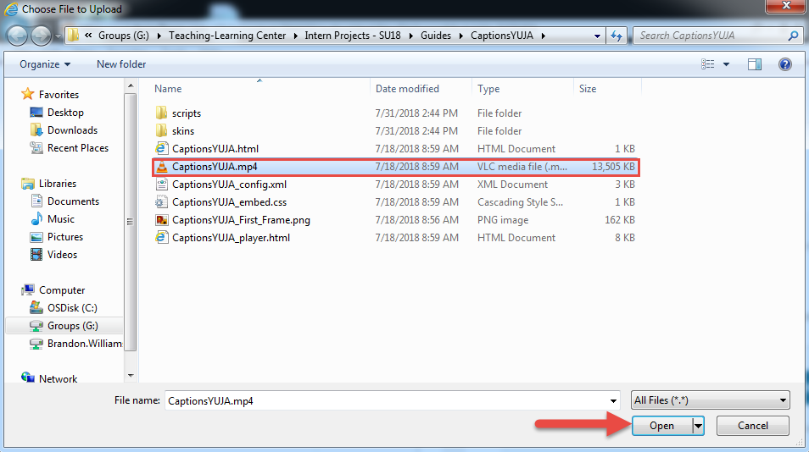

- Give your video a title, and then click Add Captions.
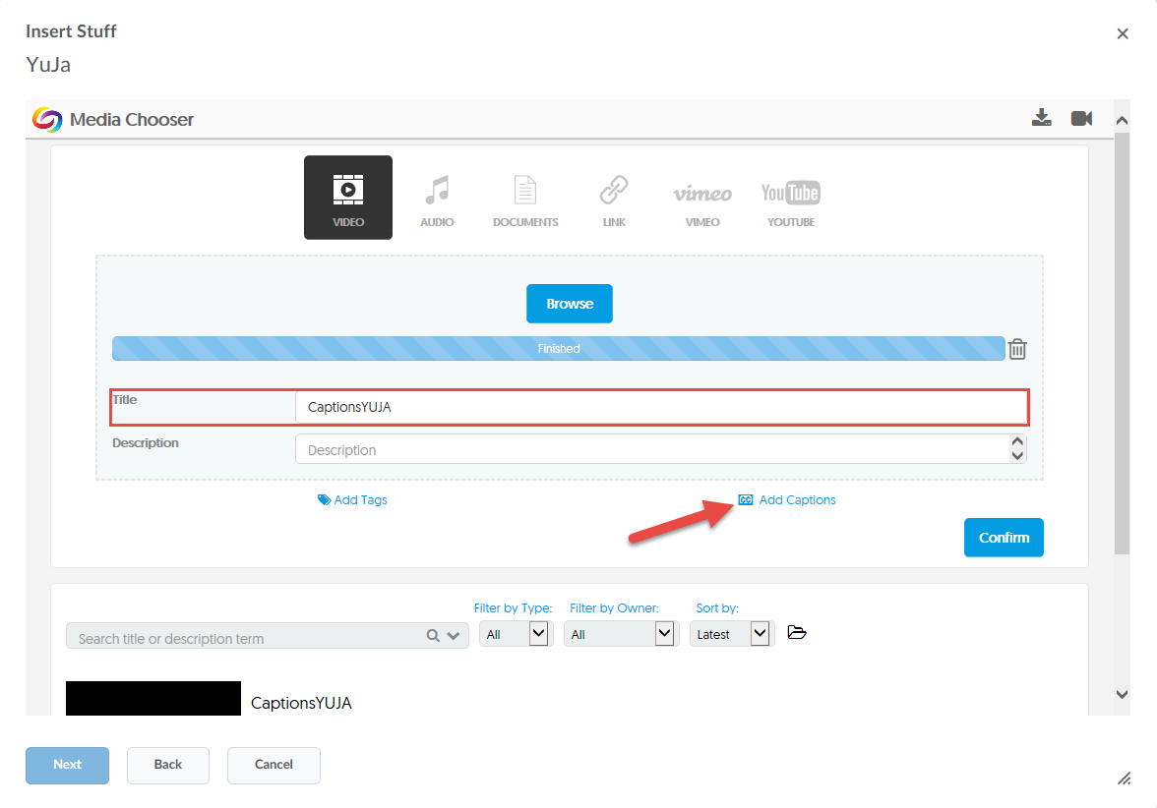

- Make sure Auto Caption and English are selected, then click Save.
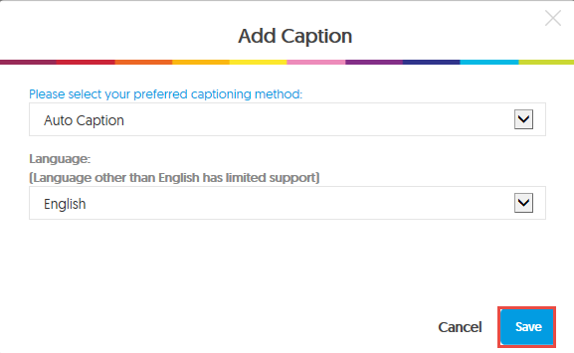

- Click Confirm.
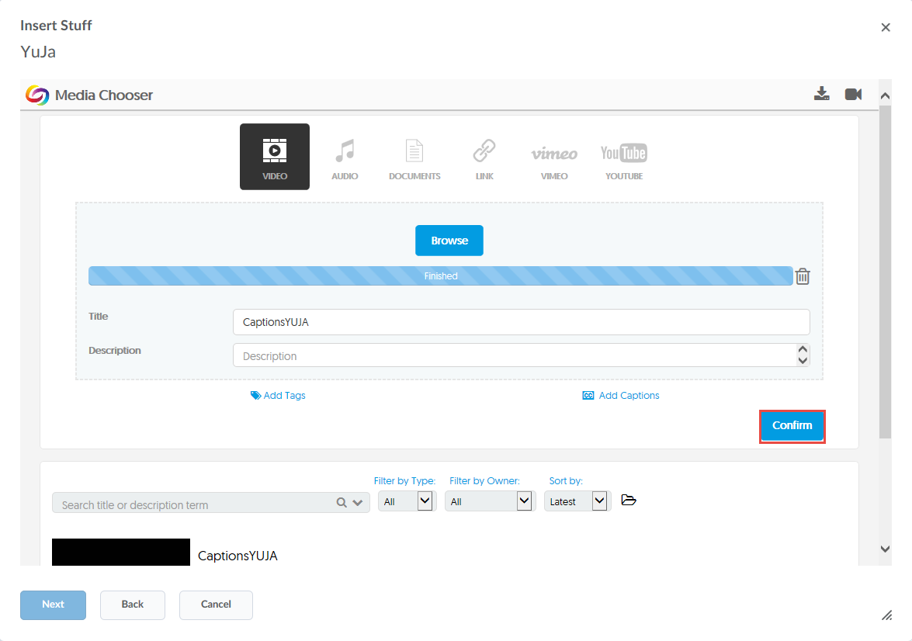

- Scroll down, find the video, and select it.
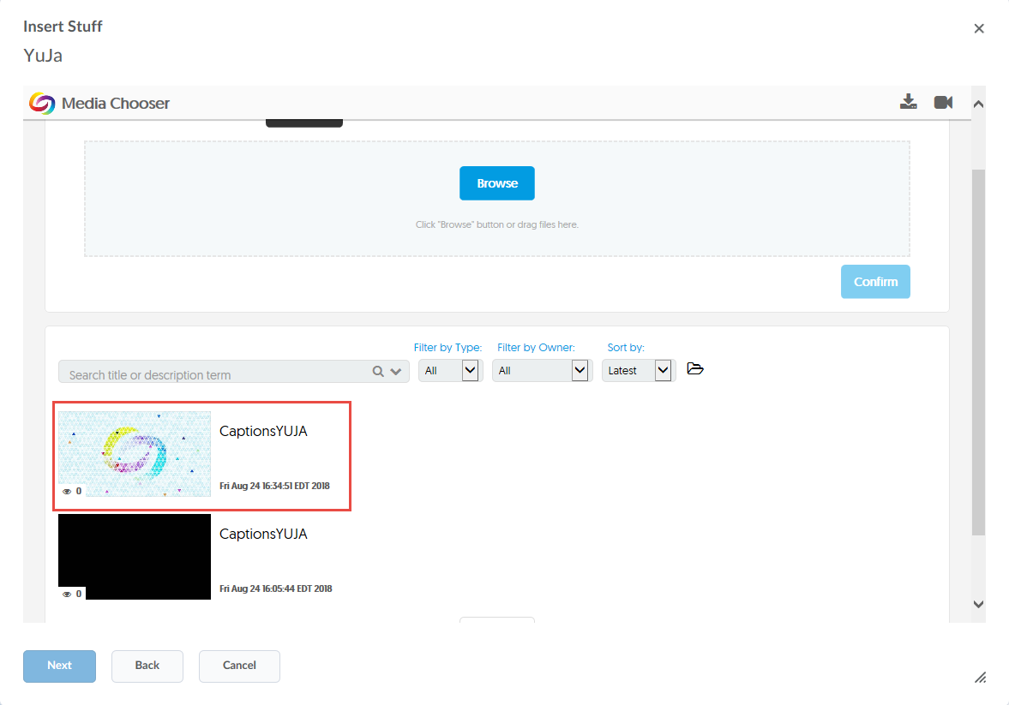

- Now click Insert.
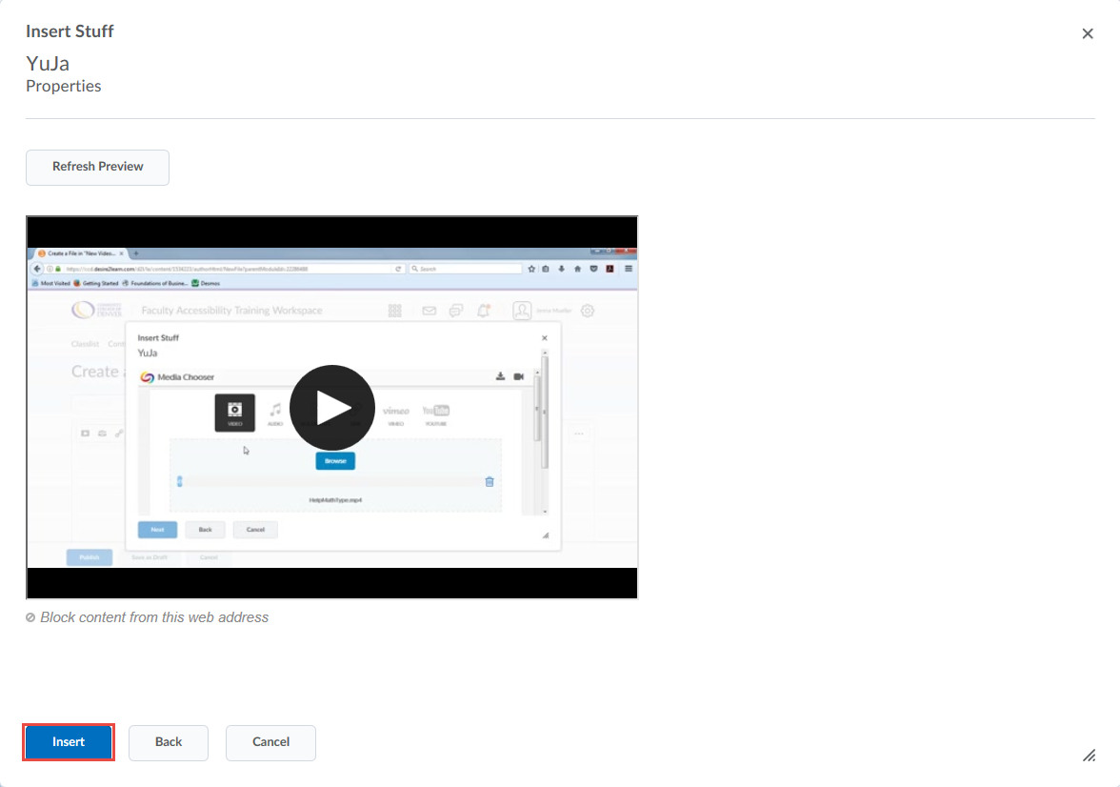

- Create a title for your file, and then click Publish.
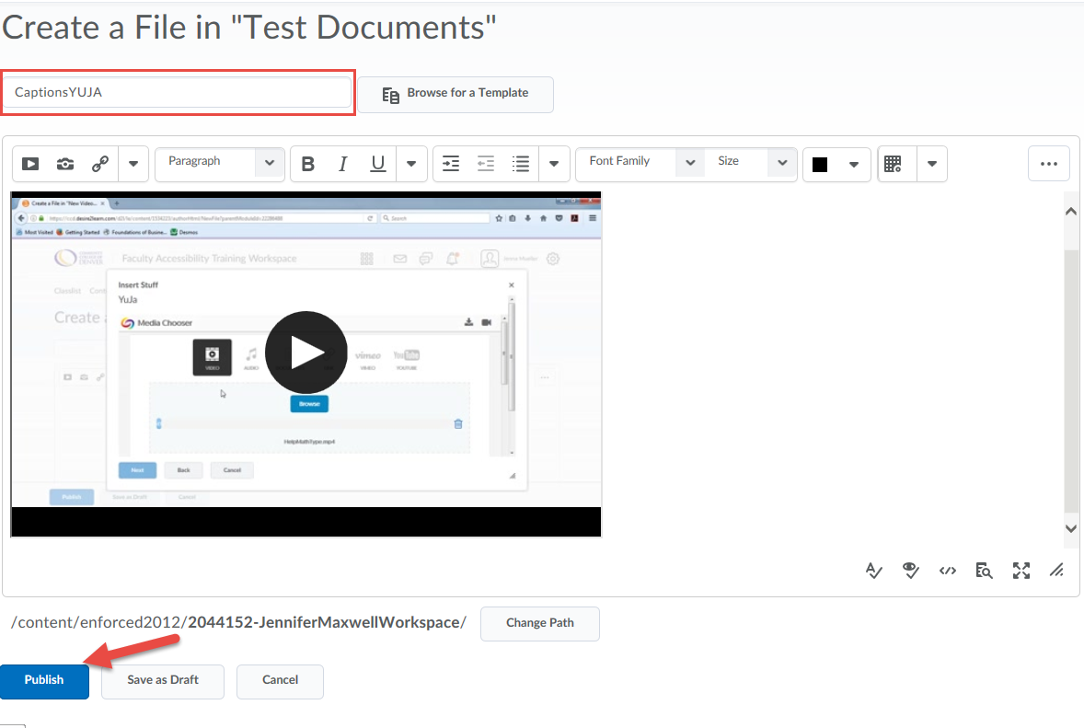
- To edit your captions, click the YuJa tab in the D2L ribbon and click the HTML5 Video Editor.
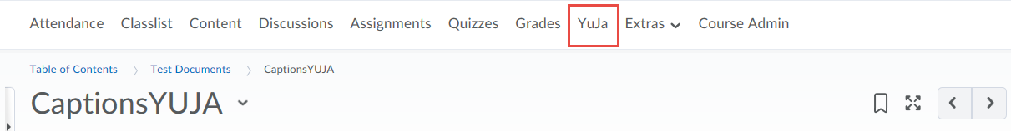
- Select HTML
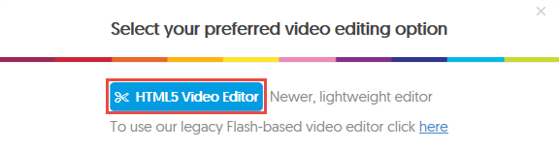

- Click the Closed Caption or “CC” icon.
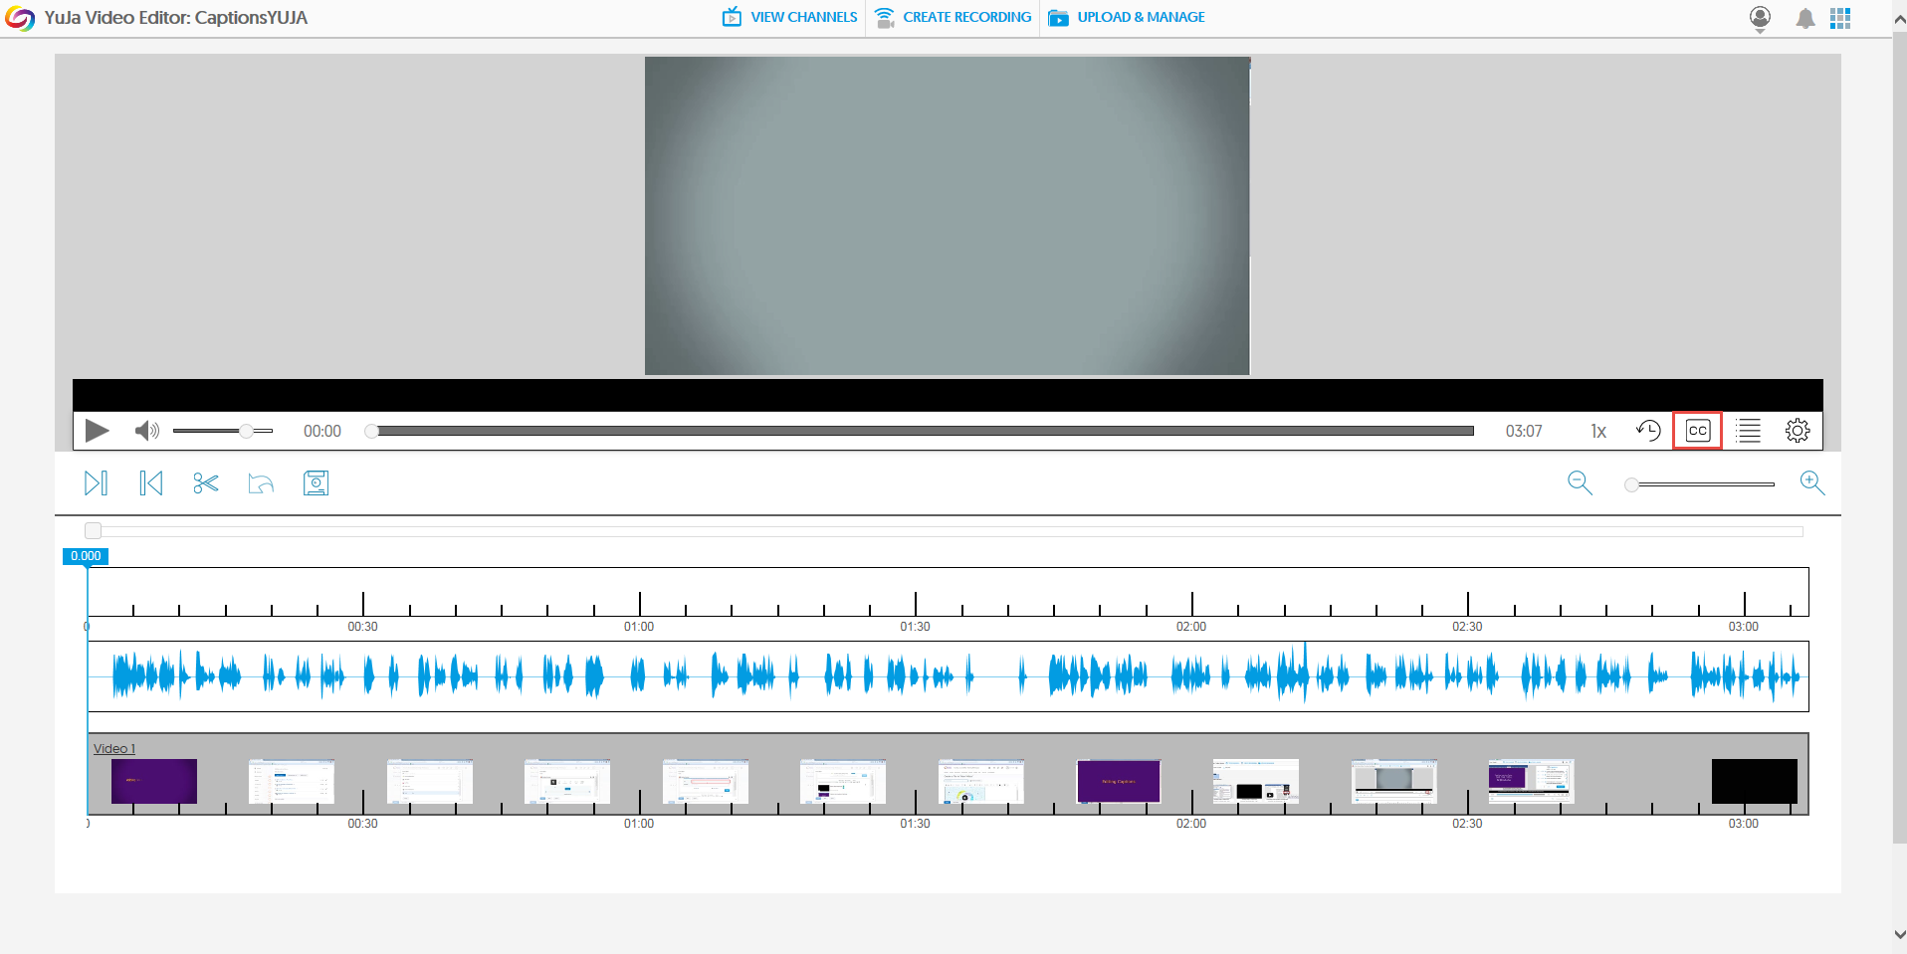

- If if the auto-captions have errors, click in its text field.
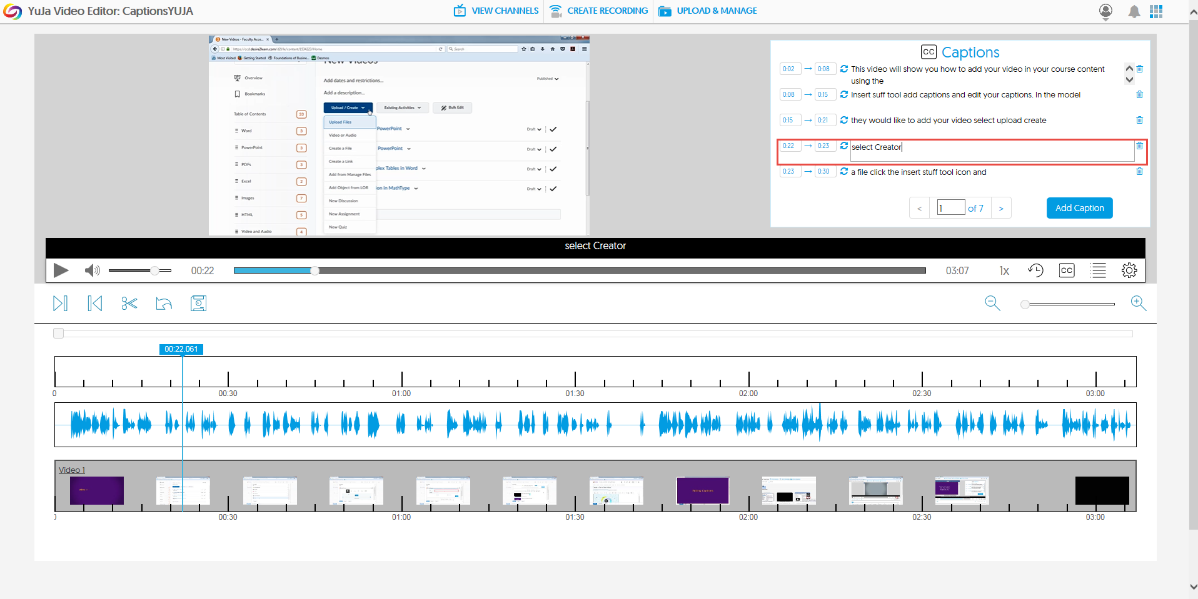

- Edit caption text as needed.
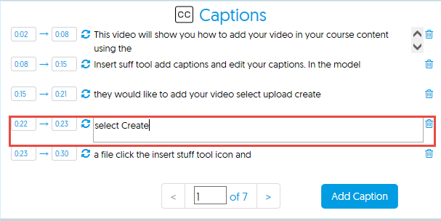

- To save your edits, click the Save icon.
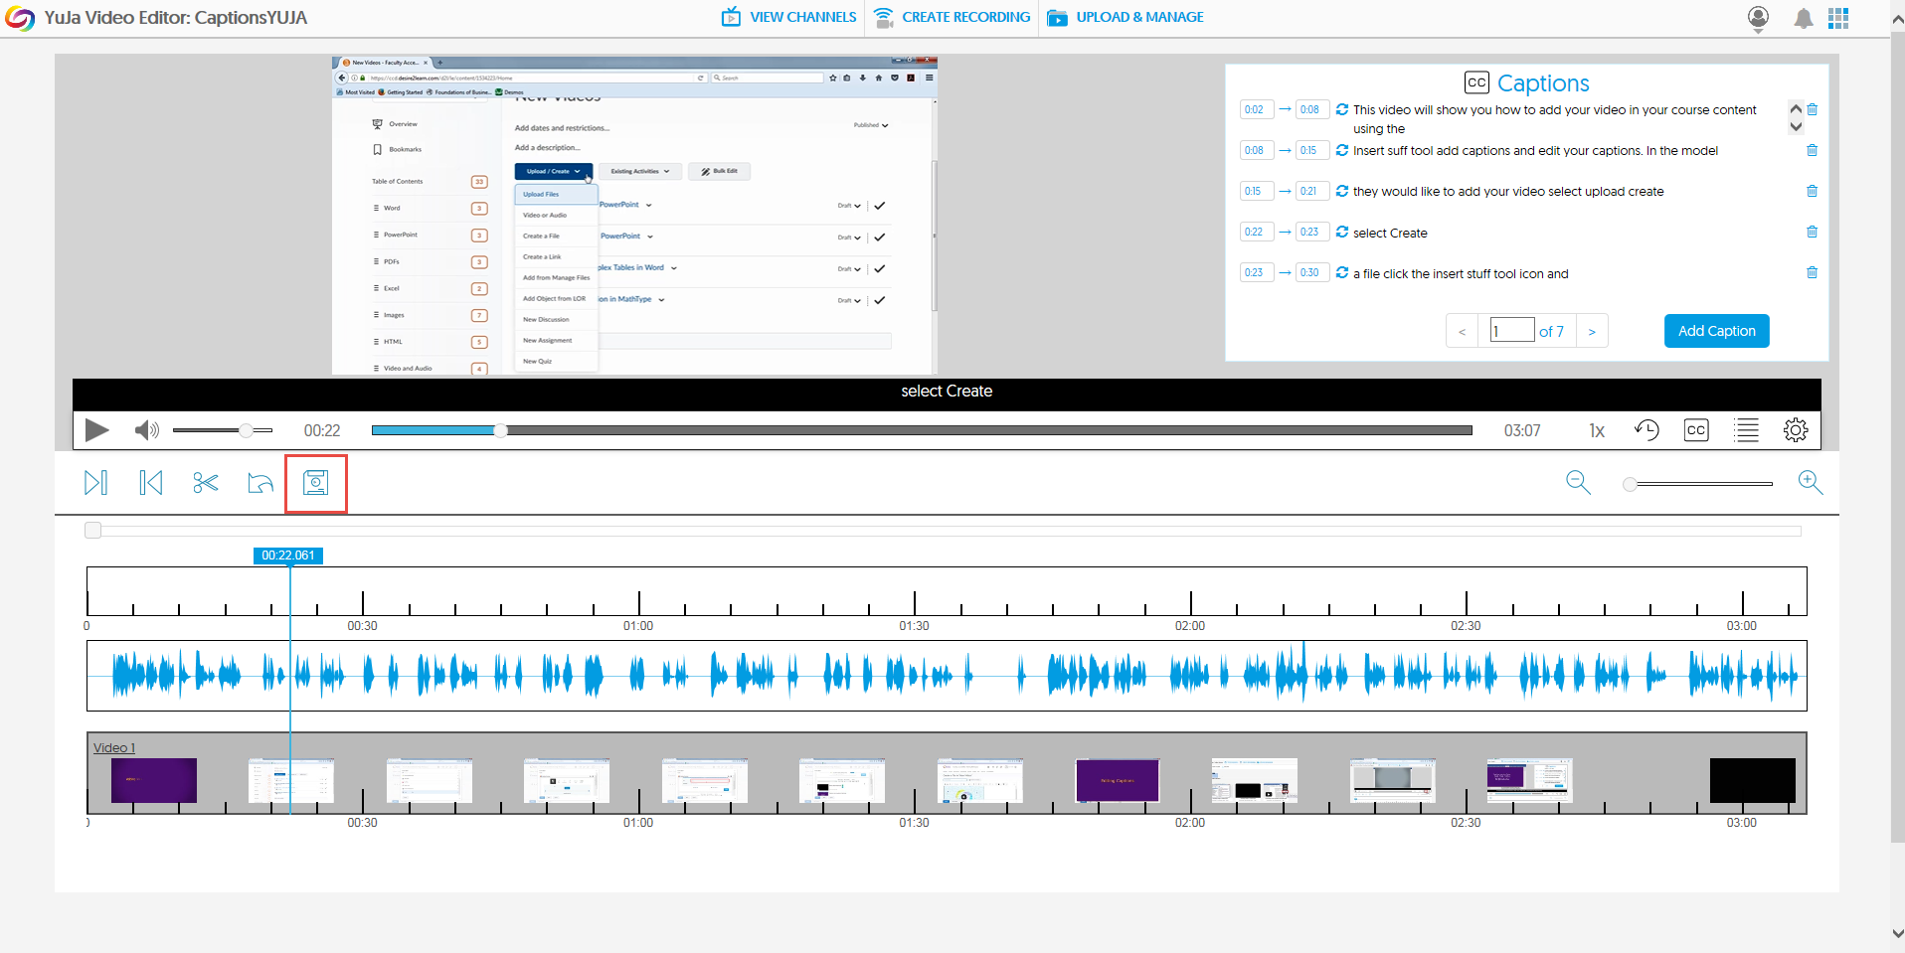

- To submit edits, click the Update Caption And Indexes button.
