How To Format Text and Check for Accessibility in PowerPoint
This document will show you how to define text styles in PowerPoint and check for Accessibility using the Accessibility Checker in order to create an accessible, navigable document.

Please do not hesitate to contact Jen at the Teaching Learning Center at
303.352.3002 or Jennifer.Maxwell@ccd.edu

Format Text for Accessibility:
- A sans-serif style (Verdana) is necessary for readability

1. Select your text.

2. Select the Home tab.

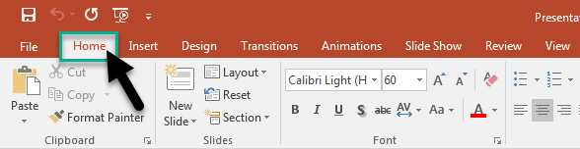

3. In the Font group, which provides options for font type, size, style, and color, select your formatting choices.
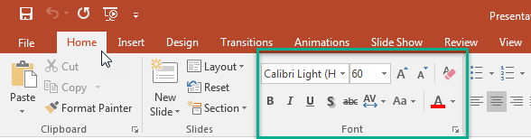

Using Accessible Text Color:
- Use the pre-designed Office Themes to make sure that your slide design is accessible. For instructions, see Developing An Accessible Slide Design.
- Use the Accessibility Checker to analyze the presentation and find insufficient color contrast. It checks the text in the slides against the following elements:
  - Page color
  - Cell backgrounds
  - Highlights
  - Text box fill
  - Paragraph shading
  - SmartArt fills
  - Headers and footers
  - Links

How to Check Accessibility with the Accessibility Checker:

1. Select File in the Ribbons tab.
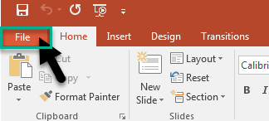

2. In File, select Info.

3. In Info, find the ‘Inspect Presentation’ section.
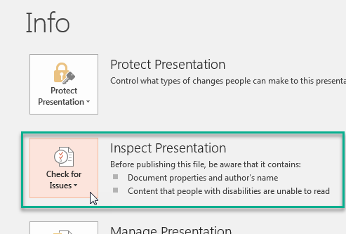

4. Select Check for Issues.
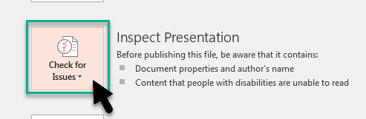

5. The dropdown menu will appear. Select Check Accessibility.
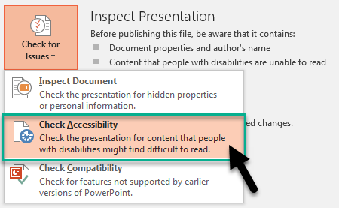

6. The Accessibility Checker will run an inspection of your presentation.

7. The results will appear on the right side of the slide.
The Accessibility Checker will give you a list of errors to correct.

