How To Use Text Boxes for Accessibility
This document will show you how to create a functional, readable alternative to text boxes in Microsoft Word.

Please do not hesitate to contact Jen at the Teaching Learning Center at
303.352.3002 or Jennifer.Maxwell@ccd.edu

Text Box Alternative: Shapes:
- Text boxes should not be used when creating a document in Word.
- The Screen Reader does not read anything in the box and the information is skipped over.

1. To create a “text box,” we will be using a rectangle shape.
Click on the Insert tab in the Ribbons tab and find the Shapes icon.

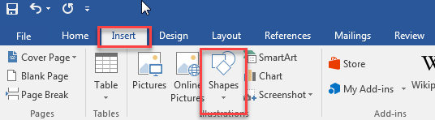

2. Click on Shapes to expand the menu.

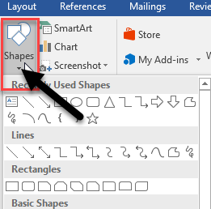
3. From the selection of Rectangles, click on the shape that best suits your needs.

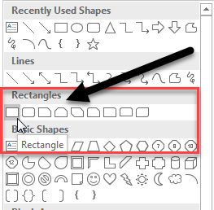

4. Find the information in you Word document that you would like to put the box around.

5. Holding the right-click down, drag the shape around your information.
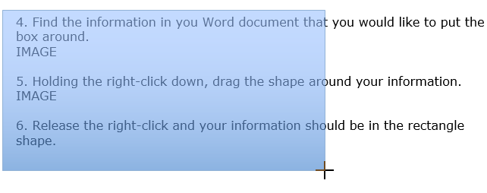

6. Release the right-click and your information should be in the rectangle shape.

7. Right-click in the rectangle shape and click on Format Shape.

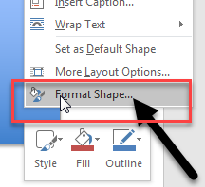

8. The Format Shape dialog box will appear on the right side of your document.

9. Click the Fill & Line icon and access the Fill feature by clicking the expand arrow.

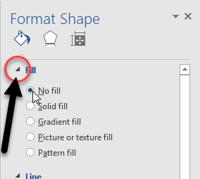

Click the radio button for No fill.

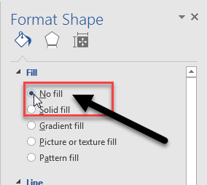

10. In the Format Shape dialog box, still in the Fill & Line icon, go down to the Line section and click the expand arrow next to Line.

11. Find the Color feature, and click on the Color icon to change the color to black.

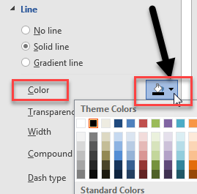

12. Your information will now appear in the rectangle shape and has the same effect as a call out text box for emphasis.
Example:
