How To Create Alt Text in PowerPoint
This document will show you how to create Alt Text for accessible images, charts, and videos in PowerPoint 2016 and PowerPoint for Office 365.

Please do not hesitate to contact Jen at the Teaching Learning Center at
303.352.3002 or Jennifer.Maxwell@ccd.edu.

Add Alt Text to Images in PowerPoint 365: https://support.office.com/en-us/article/make-your-powerpoint-presentations-accessible-6f7772b2-2f33-4bd2-8ca7-dae3b2b3ef25

Add Alt Text to Images in PowerPoint 2016:
1. Right-click an image and select Size and Position.

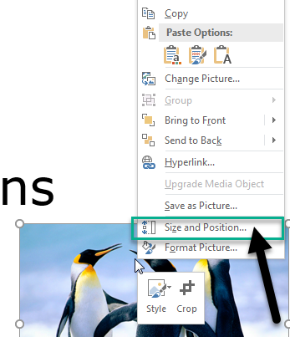
The Format Picture pane opens on the right side of the slide.

2. In the Format Picture pane, scroll down to select Alt Text.

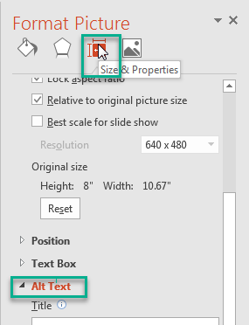

3. In the Description text box, type the alt text for the image.

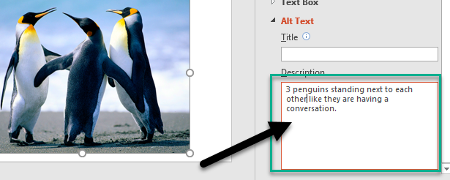

4. Clicking out of the Format Picture pane will save the Alt Text for the image.

Add Alt Text to Charts in PowerPoint 2016:
1. Right-click a chart and select Format Chart Area.

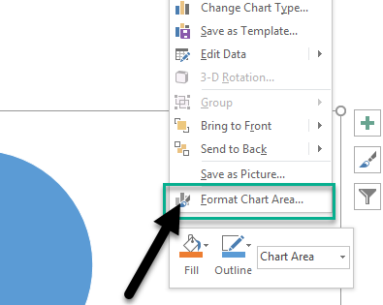
The Format Chart Area pane opens on the right side of the slide.

2. In the Format Chart Area pane, select the Size & Properties icon.

3. Select Alt Text and type a description for the chart.

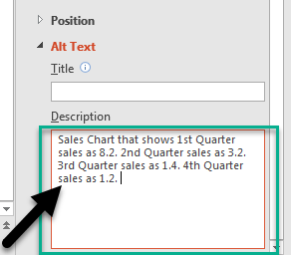

4. Clicking out of the Format Chart Area pane will save the Alt Text for the chart.

Add Hyperlink Text:
1. Select the text to which you want to add the hyperlink, and then right-click.
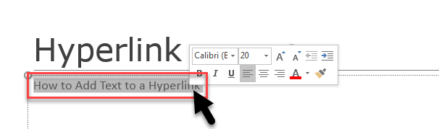

2. Select Link.
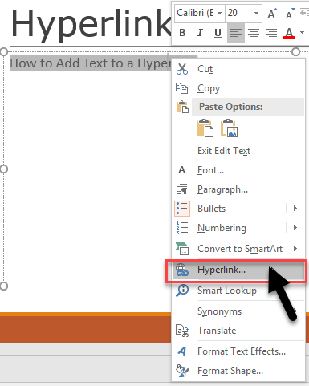

The text you selected displays in the Text to display box. This is the hyperlink text.

3. If necessary, change the hyperlink text.

4. In the Address box, enter the description address for the hyperlink.

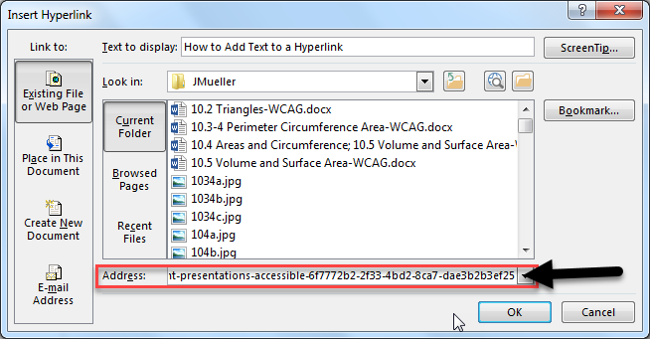

5. Select the ScreenTip button.

In the ScreenTip text box, type a ScreenTip.

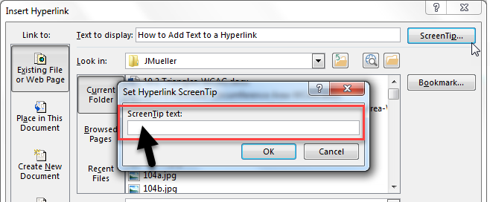

6. To apply the changes, select OK.

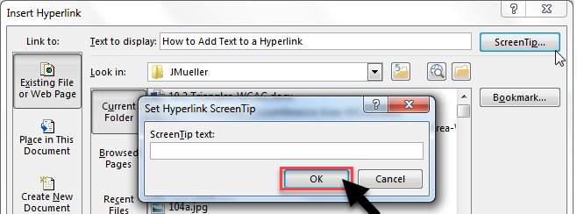

7. In the Insert Hyperlink dialog box, select OK.

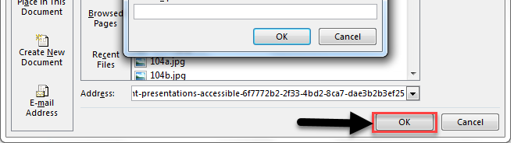

Use Captions, Subtitles and Alternative Audio Tracks for Videos:
PowerPoint 2016 supports the playback of video with multiple audio tracks. It also supports closed captions and subtitles that are embedded in video files.
Currently, only PowerPoint for Windows supports insertion and playback of closed captions or subtitles that are stored in files separate from the video. For all other editions of PowerPoint (such as PowerPoint for Mac or the mobile editions), closed captions or subtitles must be encoded into the video before they are inserted into PowerPoint.
Supported video formats for captions and subtitles vary depending on the operating system that you're using. Each operating system has settings to adjust how the closed captions or subtitles are displayed.
Closed captions, subtitles, and alternate audio tracks are not preserved when you use the Compress Mediaor Optimize Media Compatibility features. Also, when turning your presentation into a video, closed captions, subtitles, or alternate audio tracks in the embedded videos are not included in the video that is saved.
When you use the Save Media as command on a selected video, closed captions, subtitles, and multiple audio tracks embedded in the video are preserved in the video file that is saved.
To make your PowerPoint presentations with videos accessible, ensure the following:
- Videos include an audio track with video descriptions, if needed, for users that are blind or visually impaired.
- Videos that include dialogue also include closed captions or subtitles in a supported format for users that are deaf or hard of hearing.

