How To Create Accessible Math Equations
This document will show you how to create expressions and equations in Microsoft Word using MathType in order to create an accessible, navigable document for students with disabilities.

Please do not hesitate to contact Jen at the Teaching Learning Center at
303.352.3002 or Jennifer.Maxwell@ccd.edu

- Even the simplest equation, or , should be typed into MathType for consistency.

Placing your Equation in a Word Document:

1. Place your cursor where you would like your equation to go.

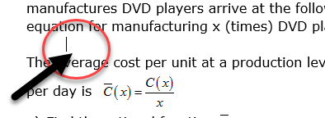

2. Click on the MathType tab in your Ribbon Tabs.

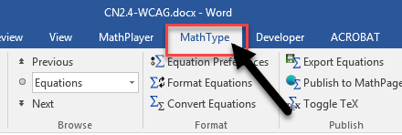

3. Click the Inline feature. This will allow MathType’s Equation editor dialog box to appear.
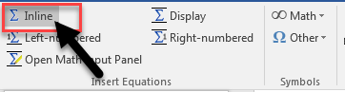

4.Type your equation into the equation editor dialog box. You DO NOT need to using spacing!

This is the equation we will be using:
4a. If you are creating a superscript use the Superscript button in the equation editor dialog box.
Click the Superscript button.

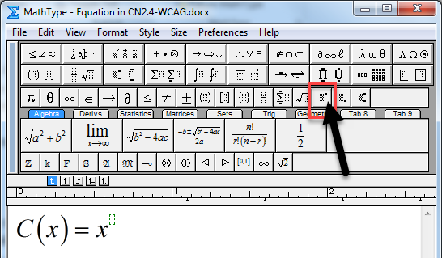
You will type your superscript in the dotted box template that appears.

Once you have finished typing your superscript, hit the tab button on your keyboard to return the cursor to the equation line.

Continue typing your equation.

5. Once you have finished typing your equation, clicking out of the equation editor dialog box will save your equation into your document.
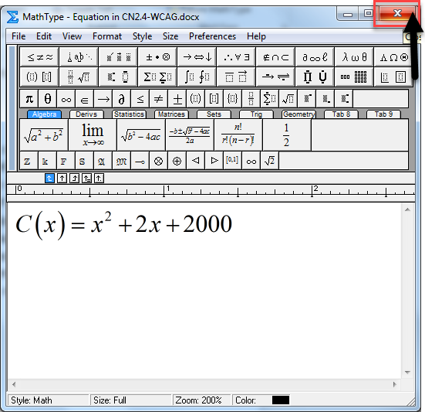

6. Your equation will appear in your document in MathType.

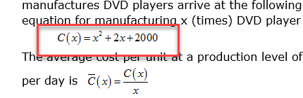

Using Text in an Equation:
- Text or words in an equation will be read by the Screen Reader as each individual letter (read as a variable) unless the text feature has been used in MathType.

1. Place your cursor where you would like your equation to go.

2. Click on the MathType tab in your Ribbon Tabs.

3. Click the Inline feature. This will allow MathType’s Equation editor dialog box to appear.

We will create this expression:

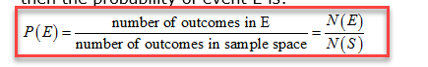

4. Start typing your expression.
4a. To create a fraction, click on the fraction menu button to pull down the menu.

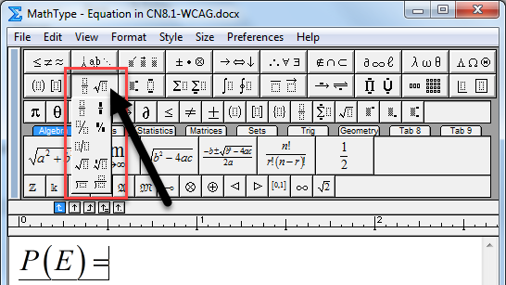

Click on the fraction template that you would like to use.

Your fraction template will appear in your equation line.

Place your cursor in your fraction’s numerator template where you would like to type the text.
5. To type in the text in the fraction, in the equation editor dialog box, click on the Style tab to access the Style menu.

6. Click Text to activate the Text in your equation.

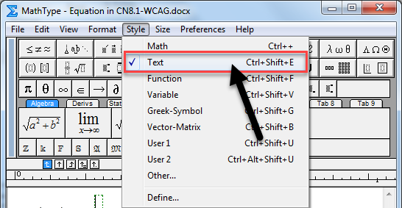

7. Type in the desired text in your fraction’s numerator template.

- If the text feature is not activated, the letters will appear in italics and has no spacing.

- This equation will not be read as words by the Screen Reader.

8. Place your cursor in the fraction template’s denominator.

9. Go back to the Style tab (1) and click on Text (2) to activate the text feature again.
- MathType will default back to Style: Math.

10. Type your words into the fraction’s denominator.

11. Hit tab on your keyboard to return your cursor to the equation line.

12. Finish typing your equation.

13. Once you have finished typing your equation, clicking out of the equation editor will save your equation into your document.

14. Your equation should appear in your document.

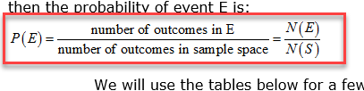

Checking your Equation for Readability:

1. Click on the equation you would like to check for readability. A dashed box will appear around the equation.

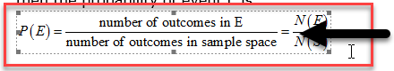

2. Click on the MathPlayer tab in the Ribbon Tabs.

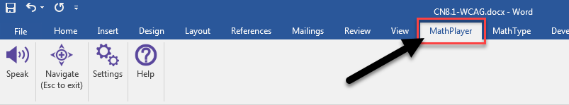

3. Click on the Speak icon to play your equation.

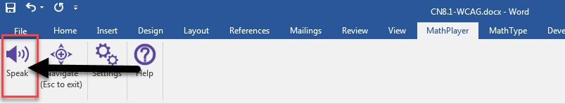

4. MathPlayer will read your equation.
- It may take a couple seconds before it begins to read.

5. If everything in your equation reads correctly, place your cursor out of the equation and continue creating your document.

Editing your Equation:
- If there is a part of your equation that does not read correctly or you have made an error.

1. Find the equation in your document that you would like to edit.

2. Double click on the equation so the MathType equation editor dialog box will appear.

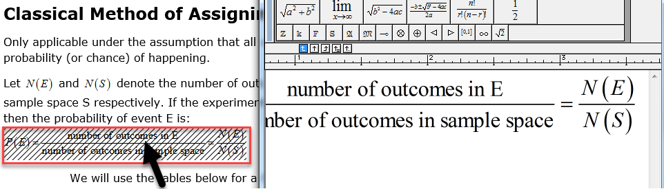

3. Place your cursor into your equation in the equation editor.

4. Edit your equation.

5. Once you have finished editing your equation, clicking out of the equation editor dialog box will save your edits to the equation in your document.

Finding Help in MathType:

1. Click on the MathType tab in the Ribbon Tabs.

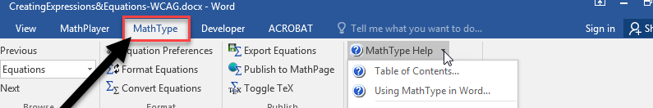

2. Hover your cursor over the MathType Help feature to activate the dropdown arrow.

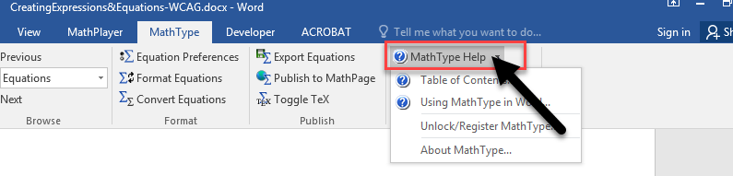
3. Click on the arrow to activate the menu.

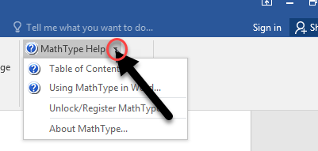

4. Click on Table of Contents.

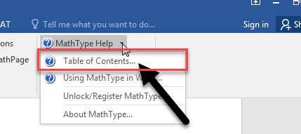

5. The Table of Contents dialog box will appear.

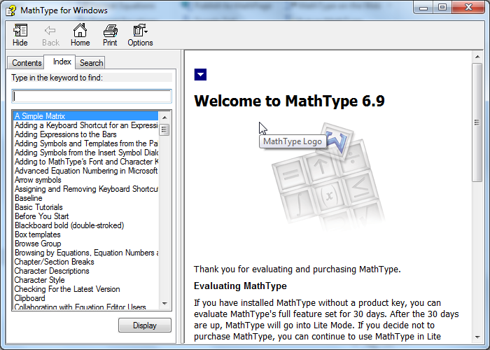

6. In the Index tab, you can type in the keyword to find tutorials.

7. If you click on the Search tab, you may type in a keyword to search. Hit Enter on your keyboard.

MathType will then provide you with list of tutorials that have that keyword in it.

8. Double click on the tutorial that you would like to view from the search results.

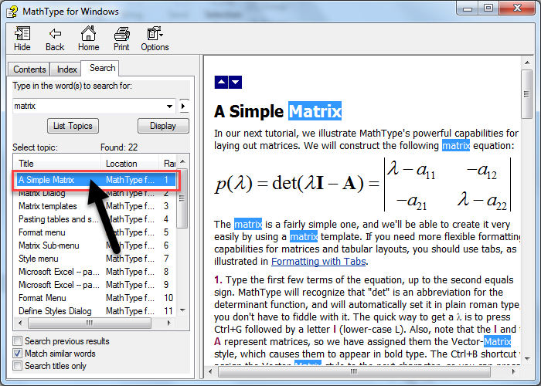

The tutorial will be shown on the right side of the window.

