How To Change Settings in Outlook
This document will show you how to change settings in Microsoft Outlook in order to create accessible, readable email messages.

Please do not hesitate to contact Jen at the Teaching Learning Center at
303.352.3002 or Jennifer.Maxwell@ccd.edu

To Change the Default Settings for Email Messages:
- A sans-serif style (Verdana) is necessary for readability.
- Do not use Stationery.

1. With your Microsoft Outlook email open, find the File tab in the Ribbon.

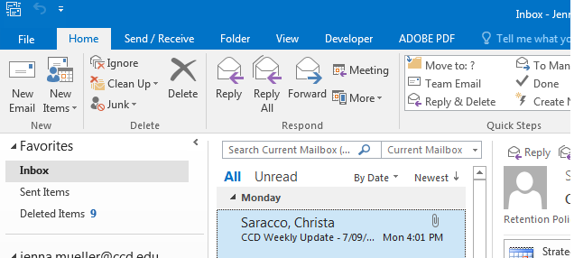

2. Click on the File tab in the Ribbon.

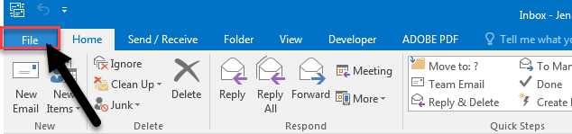

3. Click on Options in the File tab.
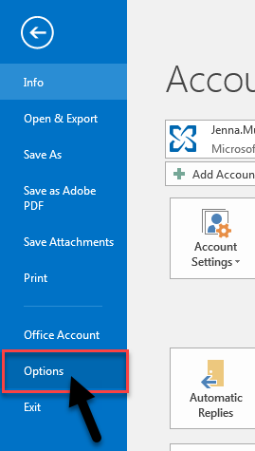

The Outlook Options dialog box will appear.

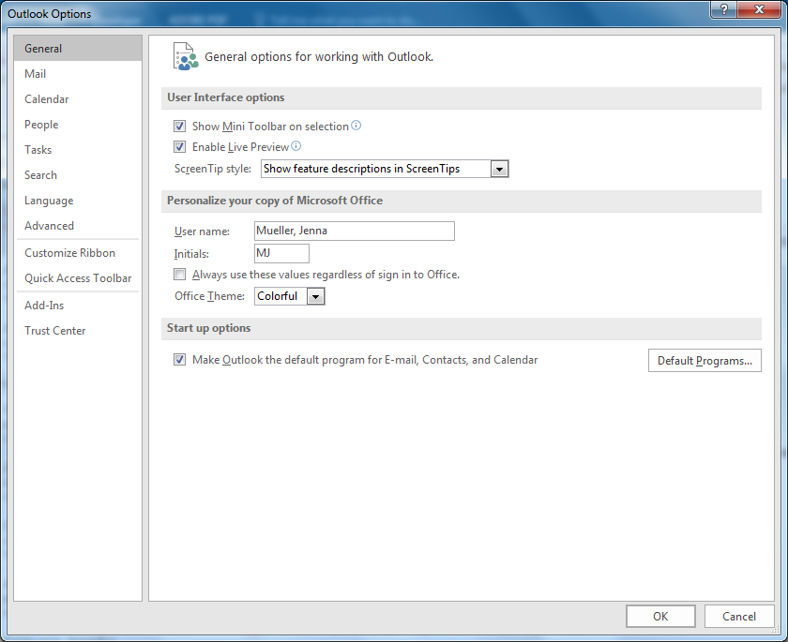
4. Click on Mail tab in the Outlook Options dialog box.

5. Click on ‘Stationery and Fonts’ in the Mail tab of the Outlook Options dialog box.

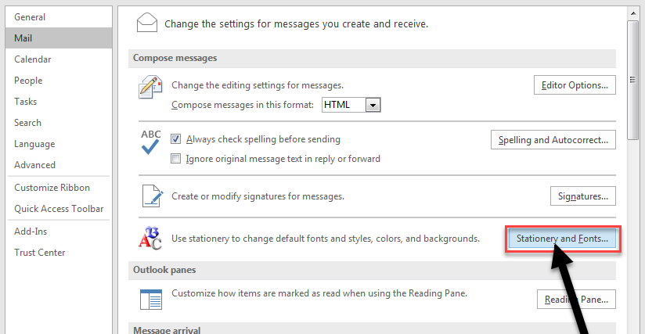

6. In the Personal Stationery tab, Click on Font in the ‘New mail messages’ section of the Signatures and Stationery dialog box.

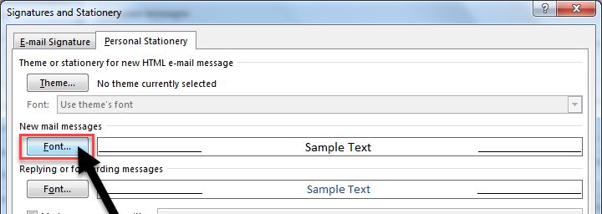

The font dialog box will appear.

7. Change font to Verdana (1), change the font style to Regular (2) change size to 12 pt (3) and color to Black (4).

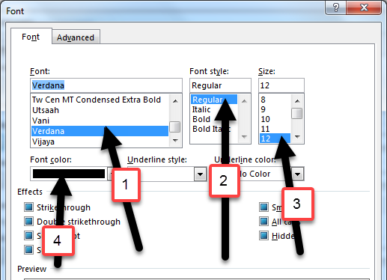

8. Click OK

9. Click on Font in the ‘Replying or forwarding messages’ section in the Signatures and Stationery dialog box.

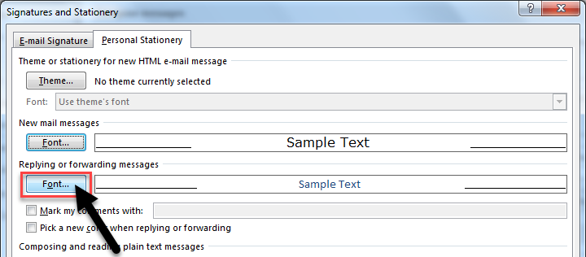

The font dialog box will appear.

10. Change font to Verdana (1), change the font style to Regular (2) change size to 12 pt (3) and color to Black (4).

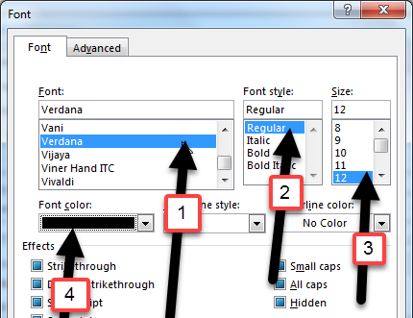

11. Click OK

12. Click on Font in the ‘Composing and reading plain text messages’ section in the Signatures and Stationery dialog box.

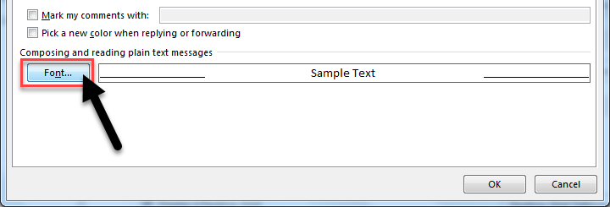

The font dialog box will appear for the ‘Composing and reading plain text messages’ section.

13. Change font to Verdana (1), change the font style to Regular (2) change size to 12 pt (3) and color to Black (4).

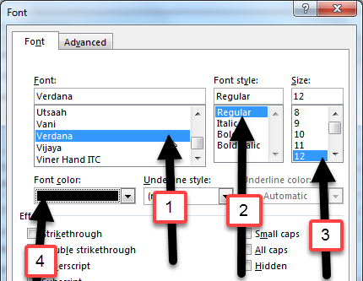

14. Click OK

15. Click OK in the Signatures and Stationery dialog box.
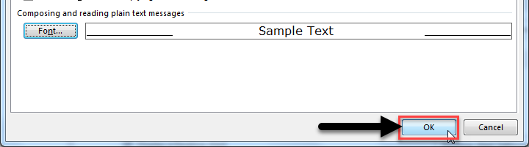

16. Click OK, in the Mail Options dialog box.

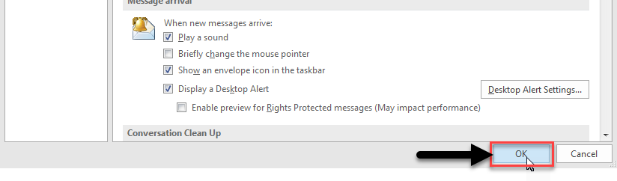

Your new font settings for email messages will be saved.

