Removing Anchors from Graphics

This document will show you how to remove anchors from graphics in Microsoft Word for students with disabilities.

Please do not hesitate to contact Jen at the Teaching Learning Center at
303.352.3002 or Jennifer.Maxwell@ccd.edu

Converting Anchored Graphics to Inline:

- Alt text within anchored graphics cannot be read by the Screen Reader and graphics need to be changed to ‘In Line with the Text.’

Example: When the Anchor icon appears on an image, the screen reader will not read this and skip over the information.
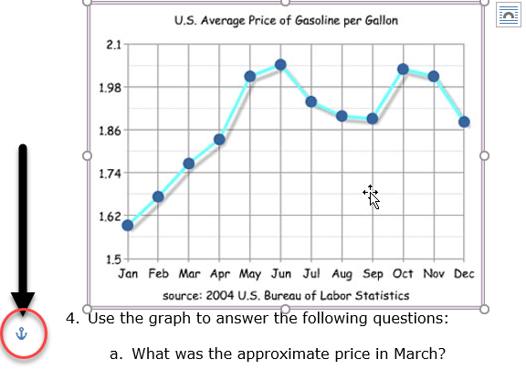

1. To remove the Anchored icon, click on the image. The Layout Options icon will appear.
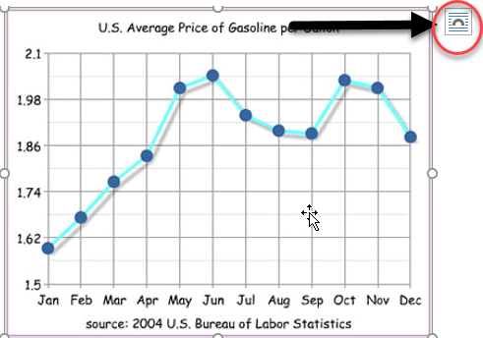

2. Click on the Layout Options icon for the Layout Options dialog box to appear.
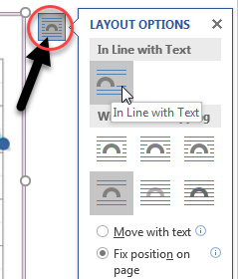

3. Click the option: In Line with Text.
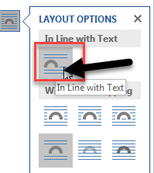

4. Your image will now by read by the Screen Reader.

